Exercise 1: https://github.com/macharstein/Private_Lab11/commit/8c0b465edb2b8da3c88a8c7074304a0fe4b262b0
Exercise 2: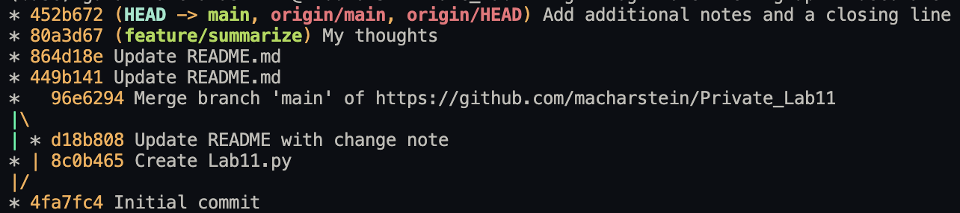
I used merge, because it was easier to understand.

Exercise 3:

